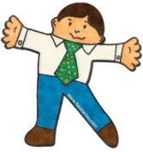
Please RETURN to your student…
- Flat Stanley
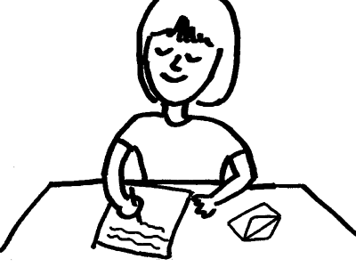
- The student’s letter that they wrote to you.
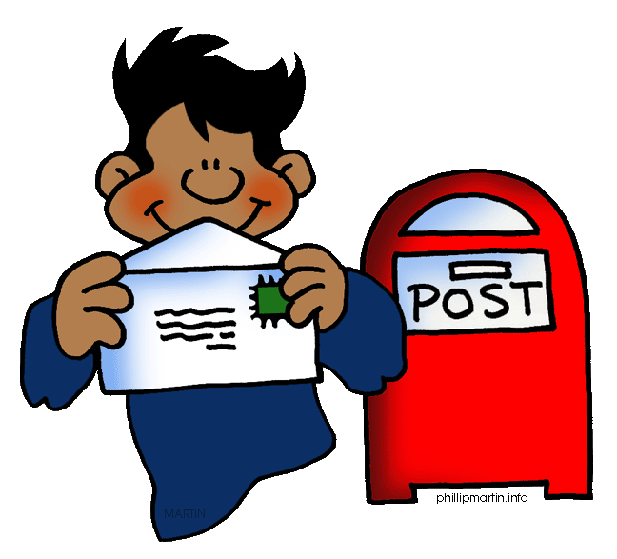
- Your letter about all of your adventures
- Pictures/Photographs
We need these items four our YEARBOOK! Thank you again. We can’t wait to hear from you!

Please RETURN to your student…
- Flat Stanley
- The student’s letter that they wrote to you.
- Your letter about all of your adventures
- Pictures/Photographs
We need these items four our YEARBOOK! Thank you again. We can’t wait to hear from you!

