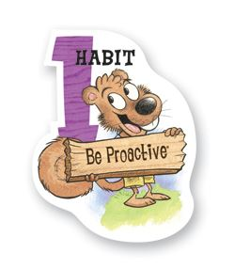
- I’m a responsible person
- I take initiatives
- I choose my actions, attitudes, and moods
- I don’t blame others for my faults
- I do good things, even when no one is
around.
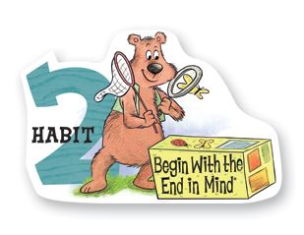
- I plan ahead and set goals
- I do things that have meaning
- I’m an important part of my class
- I figure out what I want to be
- I learn from inspiring people

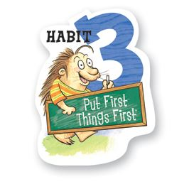
- I make my schedule
- I spend my time on important things
- I study first, then play
- I’m disciplined and organized
- I’m aware of the time

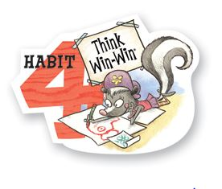
- I try to make everyone happy,
including me
- I seek for a fair solution
- I view life NOT as a competition
- I have respect for everybody
- I’m NOT a selfish person

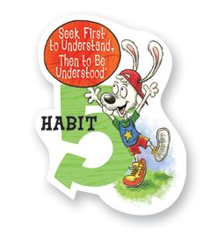
- I listen to other people’s ideas and feelings
- I listen with my eyes, ears, and heart
- I try understanding things from other
people’s view
- I DON’T interrupt whenever someone is
talking
- I’m confident voicing MY ideas

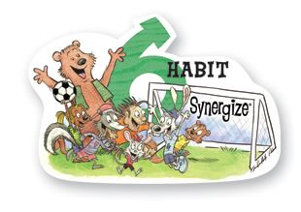
- I value other people’s differences
- Being unique is cool
- I ask for other people’s ideas
- I’m a good team player
- I can cooperate with anyone

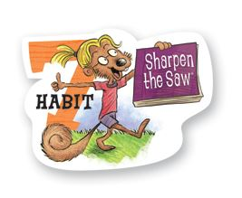
- I exercise regularly and eat healthy foods
- I can learn new things everywhere
- I spend time with my family and friends
- I believe and have hope
- I keep my mind, body, heart, and soul balanced

