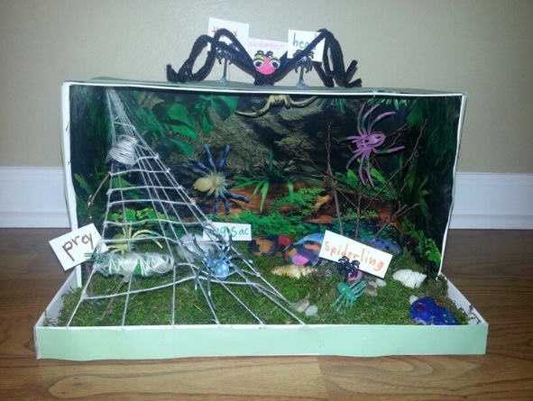
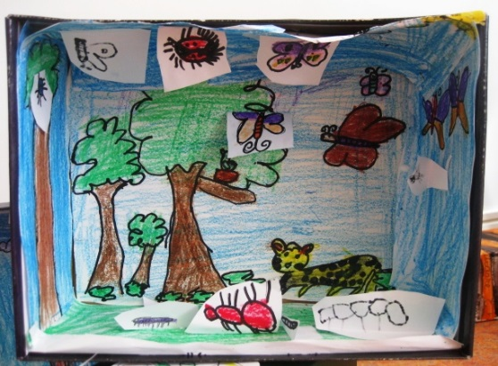
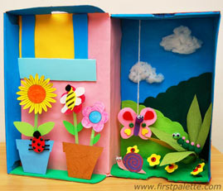

March 19, 2015

Dear Students and Family,

We are beginning our animal research project this month. Each of you have picked an animal from a different kingdom that you will focus on.
Part of the Animal Project will be making a diorama, writing about your research and giving a speech in front of the class about your animal.
What is a diorama? It is a model showing a scene with 3-D animals in miniature (mini) exhibit.
This is how your diorama will be graded:  - Animal is present 30 pts  - Animal’s food 25 pts  - Detailed Environment 25 pts  - Box decorations 20 pts  (outside decorated, label  animal, your name)  Total: 100 pts  *Diorama instructions are included on the back. | This is how your speech will be graded:  - Voice (loud) 5 pts  - Pronunciation (clear) 5 pts  - Eye Contact (all people) 5 pts  - Posture (relaxed) 5 pts  - Cover all information 10 pts  About your animal (name,  where it lives, what it looks  like, how it moves, what it  eats, who are its predators,  how we can protect your  animal)  Total: 30 pts | This is how your research report will be graded:  - Picture (cover) 10 pts  - Overview 20 pts  - Anatomy 20 pts  - Habitat 20 pts  - Interesting Facts 20 pts  - Bibliography 20 pts  - Presentation 10 pts  Total: 100 pts  *Grading Sheet attached to project

My animal is ________________________________________.
Dioramas will be due on Wed., May 31st, 2017
Thank you for your hard work students. I can’t wait to see your projects! Parents, thank you for supporting your child with this assignment.

Sincerely,

Ms. Alexander

How to make a Diorama
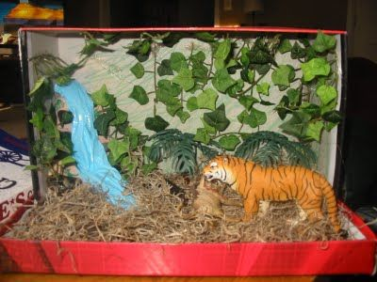
You will need:
A shoe box or similar sized box (keep lid if you have one.)
paper
pencils, crayons, markers
glue
yarn, scraps of material or anything for extra effects.
Step 1. Decide on a theme/scene
Step 2. Create a setting and background
Cut a piece a paper to fit the back (inside) of the box and two pieces for the sides.
Draw the setting on these pieces of paper. (For example; the rainforest theme would have trees and vines) Color.
Paste the setting pieces in the box.
Step 3. Add detail!
Draw and color individual pieces: (for example; the rainforest would have monkeys, snakes, butterflies, parrots, etc.).
Decide where you want these to be in the diorama.
Some should be back and some forward, some could be hanging from the top or attached to the side. You can use yarn to hang things. Use the extra materials to add the finishing touches. You can use small plastic animals, people, etc.
**HINT: To make your objects stand up...fold the bottom 1/4 inch back. Glue the bottom to the floor of the diorama. If the object falls backward make a small strip and attach it to the back of the object on one side and the other side can be attached to the back or bottom.

