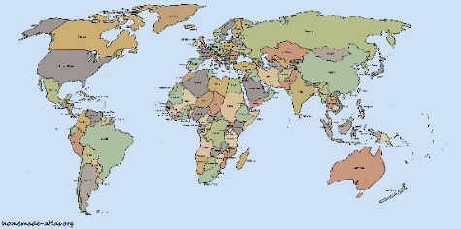
Country/State
Presentations
January 16, 2018

Dear Family and Friends,

Students will share their projects starting next weeks. Your child will present on:

_________________, January ______, 2018 at _______: _______
- This week, please help your child practice presenting their project. Use the rubric attached to remind them to use strong presentation skills and cover all of the information.
- Students are allowed, but not required, to bring index cards/notes to read off of and visual aids to use during their presentation. Students will have 2-5 minutes to share information about their country or state.
- Family and friends are welcome to join on the day your child’s presentation. I will record your child’s speech for Heritage Night.

If you have further questions or concerns, please contact me. Thank you again for supporting your child with this project. I am so excited to learn about your student and family!

Your teacher,
Mrs. Bates-Bednarski

