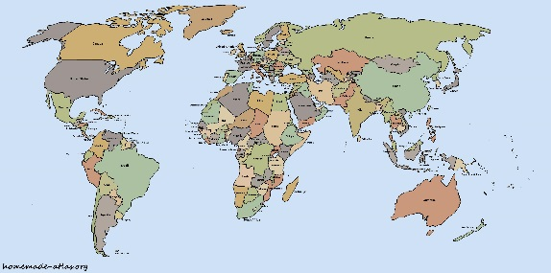
The Country/
State Report

December 3, 2018
Dear Room 21 Family,

For the next three weeks the students will be working on a Research Project about the country or state that best represents their family’s heritage. Although we will be doing parts of the report in class, they will need your help.

Your child will study: ____________________________________

Their reports will be given orally in class and be displayed at our Heritage Night on January 30, 2019 (Stay tuned for more information).
I appreciate your support with this project. It is an important part of their grade and also a great opportunity for the children to learn more about their family and it’s history. Please see the timeline, report description, outline, and grading sheet attached.

Thank you,
Mrs. Muhlbach
Room 21

