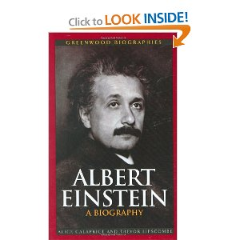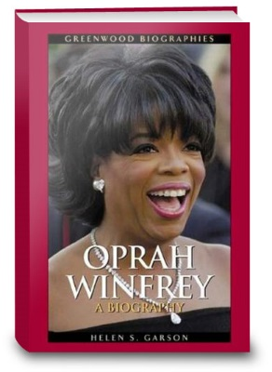

**Second Grade Biography Report**

**\*\*Choose your person by Thursday, November 10, 2016** (Return the 2nd page to Miss A)**

***The biography project is due on***

***Friday, December 2nd***

This year YOU will research an important person in history that has made a difference in our lives. We will do a biography report! *A* ***biography*** *is a report about someone else’s life.* You will **use a book** and other resources (internet, videos, magazines, newspapers, etc.) to research your person. You will share your information in a report and display it creatively on a cereal box.

**START LOOKING FOR A CEREAL BOX!**

Follow these steps for your Biography report:

**1) Get a CEREAL BOX and cover it with white/light colored paper**

-You may write directly on the paper you covered the box with OR write your information on paper FIRST and then glue it on the box AFTER. It’s up to you, but be **NEAT** and **COLORFUL**!

- Use a ruler and write lightly with pencil. Then go over your work with crayons, colored pencils, or markers.

**2) Time to add your information! On the FRONT of your box:**

* 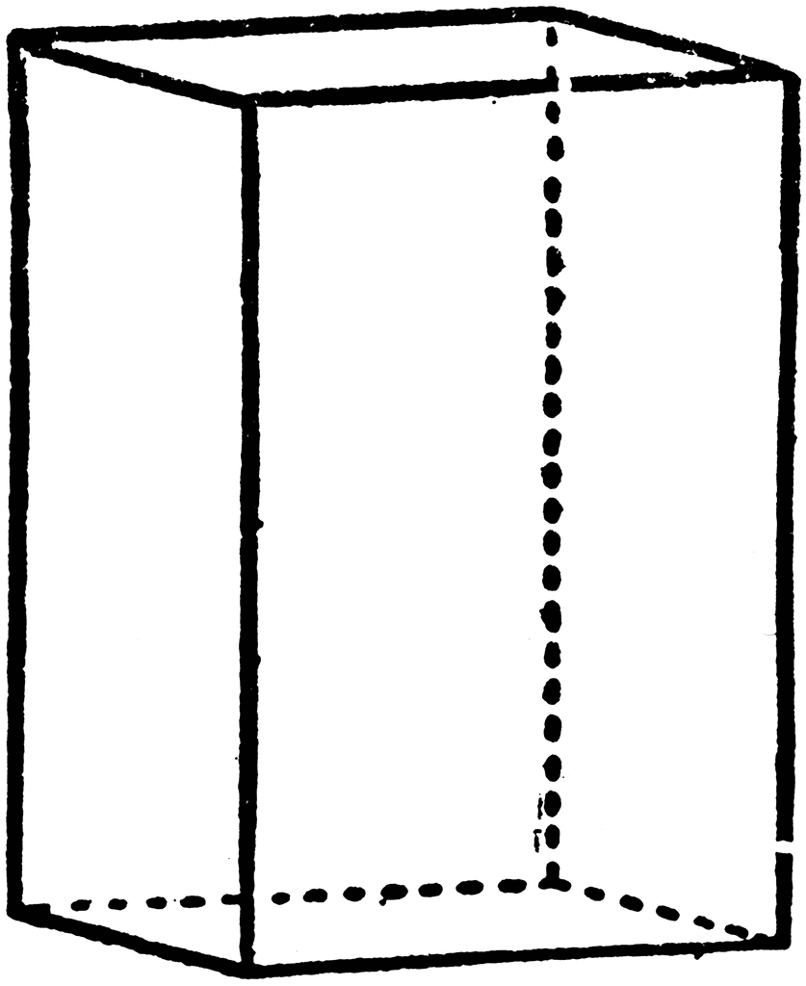The name of your person
* A picture of the person



* Your name 🡨 Front



**3) On the BACK of your box:** Back🡪



* A written report about your person

Name of Person

**Paragraph 1:** I am researching about_________. He/She was born_____ and died_____. He/She is best known for_______.

**Paragraph 2:** Here are some things _________ did in his/her life.

**Paragraph 3:**  I wanted to research _________ because ___________.

I am inspired by __________ because ___________ and I want to __________.

* + - 1st paragraph: The person’s name. Where were they born? When did they die? Why is he/she famous?
    - 2nd paragraph: What are some of their accomplishments?
    - 3rd paragraph: Why did you pick this person to research? How are you inspired by this person?

**4) On SIDE 1 of your box:**

* Give us the FAST FACTS about your person.

The FAST FACTS:

Mom: ___________

Dad: ____________

Spouse: ________________

Children: ________________________________

Close Friends: ________________________________________________

Places lived: ________________________________________________

* + Who were their parents?
  + Who is their spouse or spouses?
  + Who are their children?
  + Who are their close friends?
  + What places have they lived at?





**5) On SIDE 2 of your box:**



* Create a VERTICAL (up and down) timeline of the person’s life.

Include their birth, death, school, and large accomplishments.

**RETURN TO MISS A by Thursday, Nov. 10th**

You need to have 1 book on the person you will research. Here are some of the books I have in class that you can use, BUT you can also pick someone not on my book list:

|  |  |
| --- | --- |
| * Betsy Ross * Cesar Chavez * Dr. Seuss * Duke Ellington * George Washington * Harriet Tubman * Helen Keller * Jackie Robinson * Jane Goodall * LeBron James * Martin Luther King Jr. * Sacagawea * Sammy Sosa * Thomas Jefferson * Thomas Jefferson | * Albert Einstein * Amelia Earhart * Elanor Roosevelt * Ella Fitgerald * George Washington Carver * John F. Kennedy * Levi Strauss * Louis Braille * Mae Jeminson * Marc Brown * Mother Teresa * Pocahontas * Rosa Parks * Steve Jobs |

------------------- return ---------------

Your Name: _____________________________________

We don’t want anyone to have the same person as you, so **choose 3 people are you interested in**? ***You will study 1 of the people you listed.***

1. ___________________________________________________

2. ___________________________________________________

3. ___________________________________________________