I am studying____________________
Biography Report:Calendar

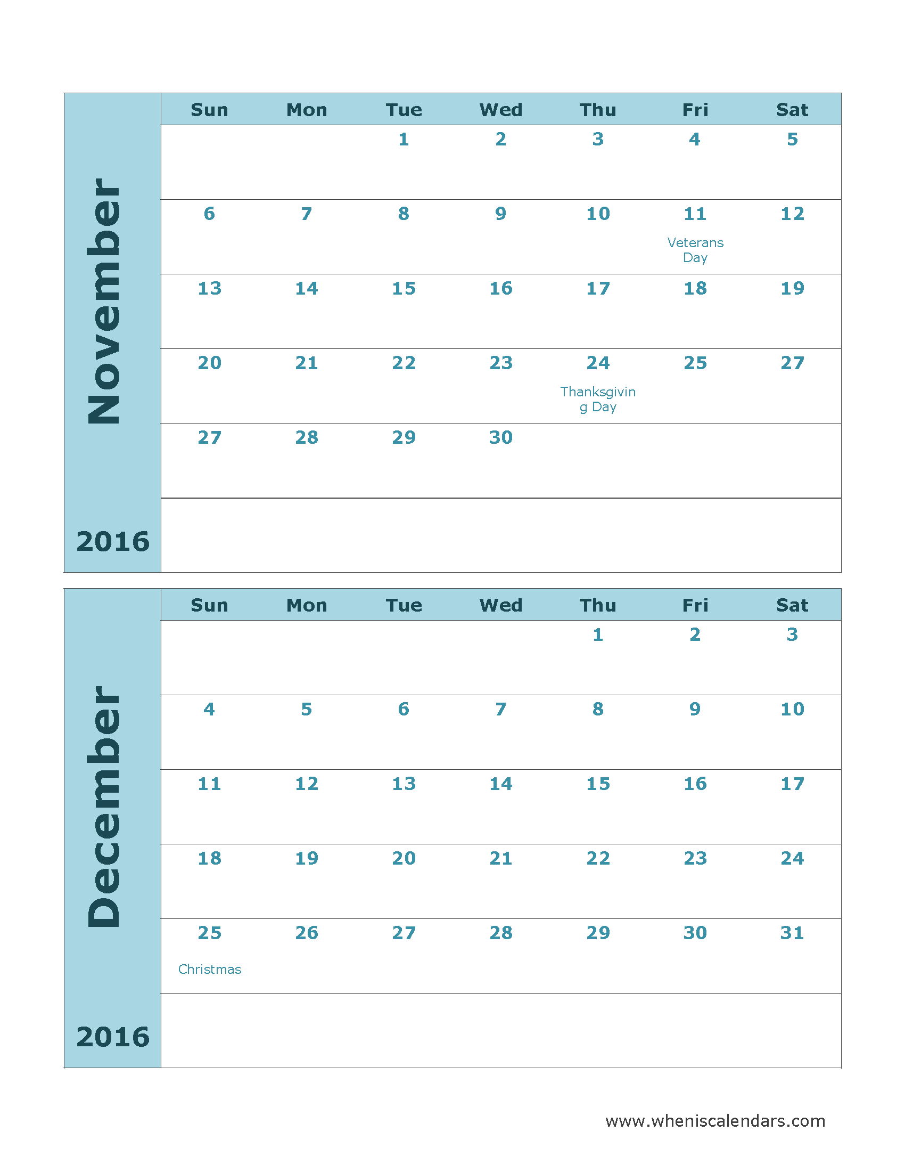
This will help you keep track of what is due each week for the Biography Project! I want to check in with you and your project, to make sure you are focused and have support (help)!

Top 3 Choices NO SCHOOL
(Yellow paper)

Info. Paper
(Back of Box)

NO SCHOOL ----------------------------------------

Timeline & Fast Facts
(side of box)

Biography
Project Due

Presentations -----------------------------------------

Presentations -------------------------

NO SCHOOL -------------------------------------------

Attached in this packet, you will find the parts of your project I will be checking on each week! You can use the papers I give you, OR you can change them and make them BETTER for YOUR project.
**Just make sure you have the same information**

(Front of the box)DUE December 2nd
Name of person, Picture, Your name
----------------------------------------------------------cut--------------------------------------------------------

Name of Person you are studying

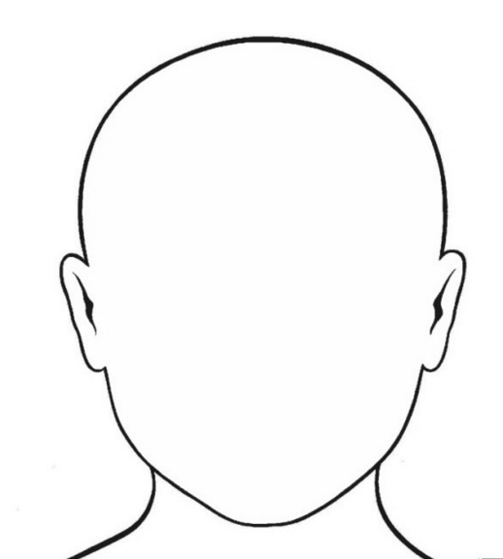

Written and Illustrate by _____________________________________________________
(Back of Box) CHECK-IN DUE November 16s^{th}
Information About Your Important Person

Here is what you need to include in your writing:

Name of Person

Paragraph 1:
I am researching about_________. He/She was born_____ and died_____. He/She is best known for_______.

(skip a line)
Paragraph 2:
Here are some things _________ did in his/her life. (Share 3 or more accomplishments the person did in their life)

(skip a line)
Paragraph 3:
I wanted to research _________ because ___________.
I am inspired by __________ because ___________ and I want to __________.

Go to the next page for your paper

__________________________________________________________

(Side of Box)CHECK-IN DUE November 30th
Side 1: Resources and Books Used to do Research Side 2: Top 3/5 Accomplishments
----------------------------------------------------cut------------------------------------------------------

The Fast Facts

Family
Mom: _______________
Dad: _______________
Siblings:
______________________________________
Spouse:
______________________________________
Children:
______________________________________
Close Friends:
______________________________________
Places Lived:
______________________________________
Life Timeline

