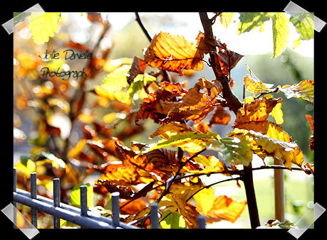
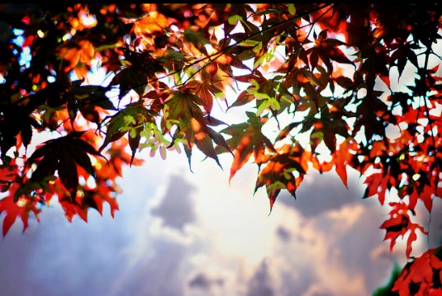
Fall
Leaves change color
And drop from the trees.
Squirrels find food for winter.
A cool wind blows.
Autumn is the best time for all!

Explain what changes happen during fall for animals and the Earth.
“During fall many things change because . . .”
______________________________________________________________________________________________________________________________________________________________________________________________________________________________________________________________________________________________________________________________________________________________________________________________________________________________________________________________________________________________________

