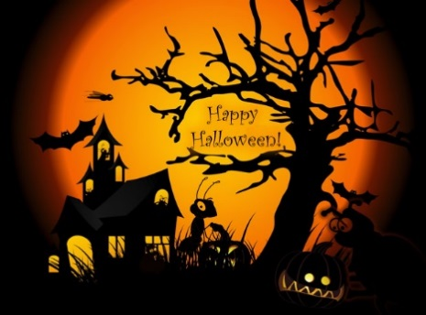
Halloween on Silly Street
There is street in my town
Where I went to trick-or-treat.
But instead of candy, I got
Silly things to eat.
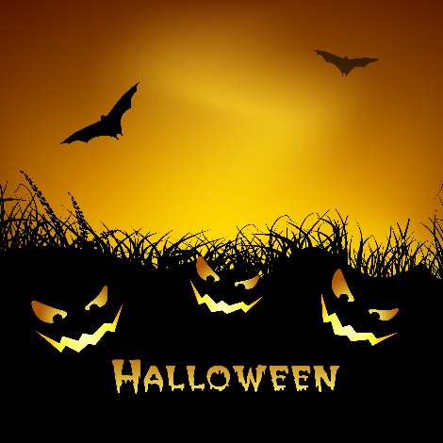
One lady gave me lima beans,
One gave me shredded wheat,
One gave me chicken gumbo
And one gave me roasted meat!
I think that was a silly trick,
And not a tasty treat!

Share a special memory your favorite trick-or-treating night.
“My favorite time trick-or-treating was when . . .”
______________________________________________________________________________________________________________________________________________________________________________________________________________________________________________________________________________________________________________________________________________________________________________________________________________________________________________________________________________________________________

