Bravery
When we face something frightful,
We don’t need to hide.
We have built-in protection
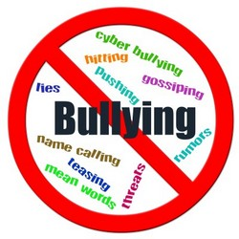
That acts as our guide.

When you feel afraid,
What things might you do
To call upon your confidence
To take care of you?

Share a time you afraid of something and you had to be BRAVE to overcome your fear.
“One time I was scared about ________. This is how I was brave and overcame my fear. I ___________ . . .”
___________________________________________________________________________________________________________________________________________________________________________________________________________________________________________________________________________________________________________________________________________________________________________________________________________________________________________________________________________

