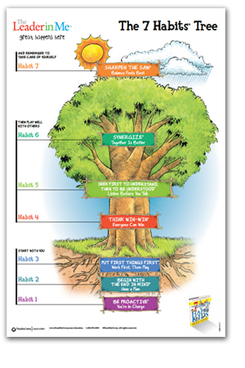

7 Habits
of a
HAPPY Me
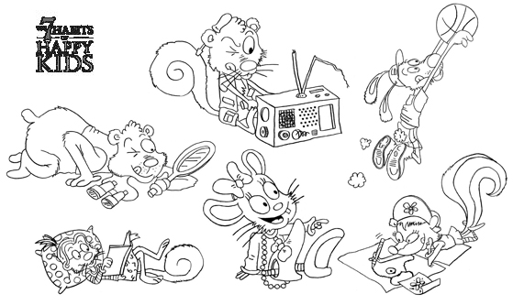
___________

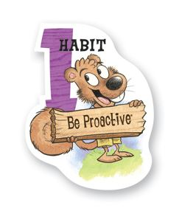
What does proactive mean?
________________________________________________________________________________________
What’s your GOAL to be more PROACTIVE?
________________________________________________________________________________________
Where will you start? What’s your plan?
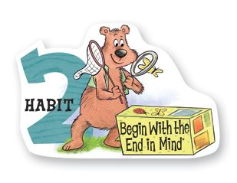

Think of some activities you want to accomplish this year.
How will you be PROACTIVE and make it happen?

THE Plan | The END Goal
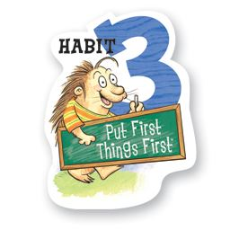
Use the pictures. Write the activity on the correct sides
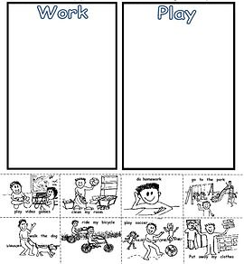

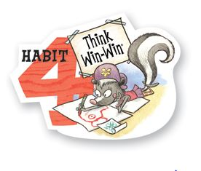
Show & Tell a WIN WIN moment

LOSE LOSE moment | LOSE WIN moment

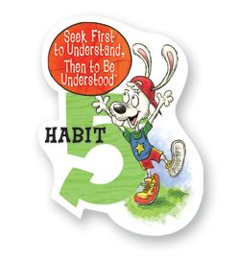
What will you do to be a good friend to another person?
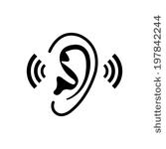

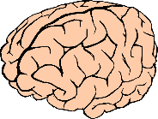

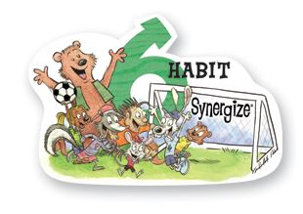
What is your favorite GROUP activity or game?
__________________________________________

How will you make sure everyone gets to help the team get a WIN WIN?

________________________________________________________________________________________________________________________________________________________________________________________________________________________________________________________________________
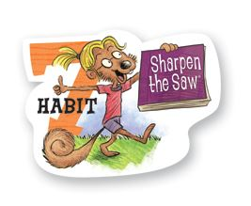
How will you stay BALANCED?

