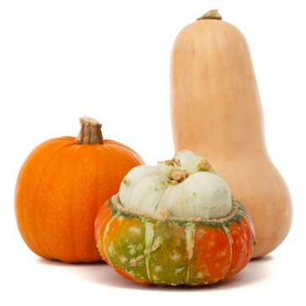
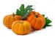
My Pumpkin
One day I found two pumpkin seeds.
I planted one and pulled the weeds.
It sprouted roots and a big, long vine.
A pumpkin grew; I called it mine.
The pumpkin was quite round and fat.
I really am quite proud of that.

Share your special memory of using or eating pumpkins.
“I remember a time when I used pumpkins for . . .”
______________________________________________________________________________________________________________________________________________________________________________________________________________________________________________________________________________________________________________________________________________________________________________________________________________________________________________________________________________________________________

