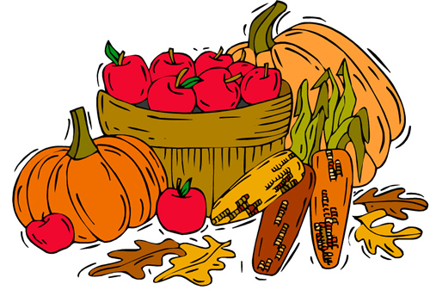
October Haiku
October morning
Puffs of cold breath
In the colder air.

When you think of October, what special moments come to your mind?
“When I think of October, I remember . . .”
______________________________________________________________________________________________________________________________________________________________________________________________________________________________________________________________________________________________________________________________________________________________________________________________________________________________________________________________________________________________________

