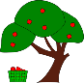
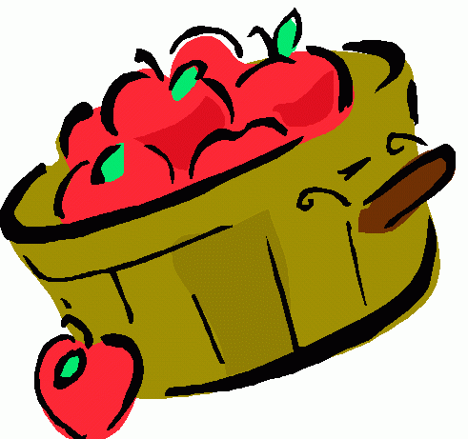
Apples, Apples
Apples Juicy, apples round;
On the tree or on the ground.
Apples yellow, apples red,
Apple pie and juice and bread!
Apples crunchy, apples sweet;
Apples are so good to eat!

What do you like most about apples? Are there other fruits that you enjoy eating?
“My favorite fruit to eat is ___________ because one time I . . . ”
________________________________________________________________________________________________________________________________________________________________________________________________________________________________________________________________________________________________________________________________________________________________________________________________________________________________________________

