Friendship
When we are in need,
Others will be there.
With their help and kindness
They show friendship and care.
Did someone do something
When you were feeling bad,
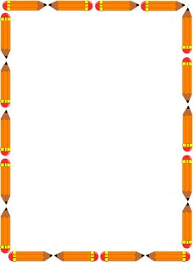
That really let you know
What a good friend you had?

Talk about your important friend. Share a time that your friend was there for you when you needed them most.
“I remember a time when my friend . . . ”
______________________________________________________________________________________________________________________________________________________________________________________________________________________________________________________________________________________________________________________________________________________________________________________________________________________________________________________________________________________________________

