Our School Year
Our school year is almost done.
We have all had lots of fun.
We’ve learned to read and write so well. So many words we’ve learned to spell.
Soon, we’ll play out in the sun.
Yes, our school year is almost done.
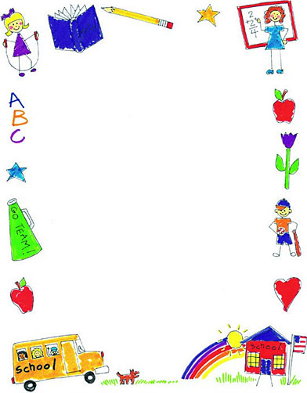

Share your best memory of Second Grade. What do you have planned for summer?
______________________________________________________________________________________________________________________________________________________________________________________________________________________________________________________________________________________________________________________________________________________________________________________________________________________________________________________________________________________________________________________________________________________________________________________________________________________________________________________________________________________________________________________________

