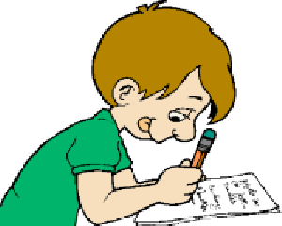
Determination
When the wind is blowing strong,
We’ll keep moving right along.
We’ll find a way to where we’re going.
Determination is what we’re showing.

Is there something you’ve been trying
That seems to hard to do?
If you have faith that you can do it,
You will SURELY see it through!

What goal do you want to finish the most? How will you reach your goal?
“My goal is to . . . I will achieve my goal by. . .”
_______________________________________________________________________________________________________________________________________________________________________________________________________________________________________________________________________________________________________________________________________________________________________________________________________________________________________________________________________________________________________________________________________________________________________________________________________________________________________________________________________________________

