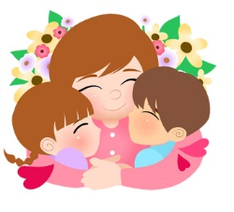
Mommy and Me
Best friends forever mommy and me
picking flowers and climbing trees.
A shoulder to cry on, secrets to share
warm hearts and hands that really care.

Share your most memorable memory with your mom. Why is your mom important to you?
“I can remember a time with my mom when…”
______________________________________________________________________________________________________________________________________________________________________________________________________________________________________________________________________________________________________________________________________________________________________________________________________________________________________________________________________________________________________________________________________________________________________________________________________________________________________________________________________________________________________________________________________________________________________

