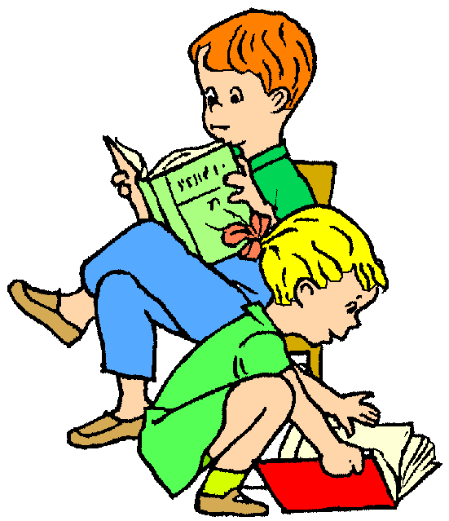
Bookworm
I slip inside a book
To see what it’s about.
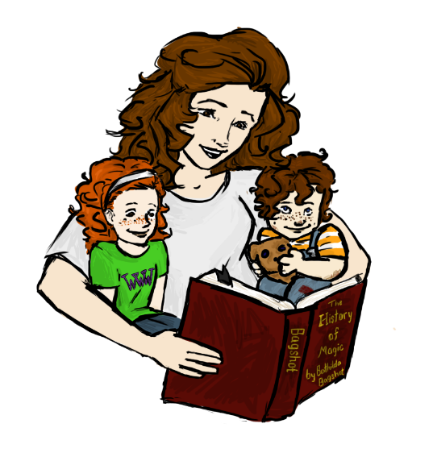
But one I am inside,
I cannot get back out . . .
Until
I reach
The end.
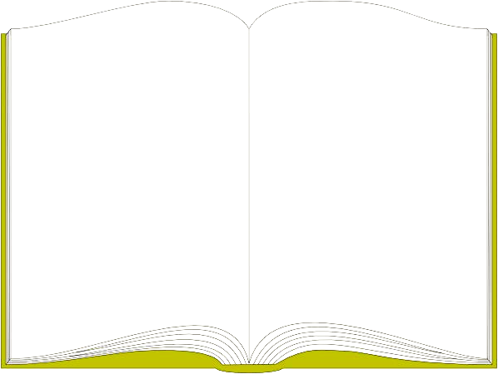

Explain which book is your favorite to read.
“My favorite book is . . . because . . .”
______________________________________________________________________________________________________________________________________________________________________________________________________________________________________________________________________________________________________________________________________________________________________________________________________________________________________________________________________________________________________________________________________________________________________________________________________________________________________________________________________________________________________________________________

