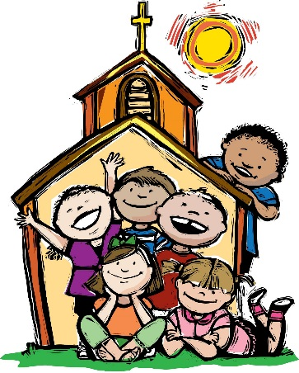
I like School
I like to go to school,
To work and learn and play
I like to meet my fiends there—
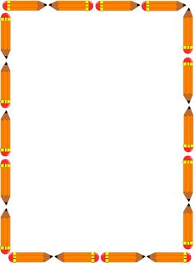
I think I just might stay.

Talk about what you like to do in school and your goals for second grade.
“What I like to do in school is . . .
My goals this year in second grade are . . . ”
____________________________________________________
____________________________________________________
____________________________________________________
____________________________________________________
__________________________
__________________________________________________________________________________________________________________________________

