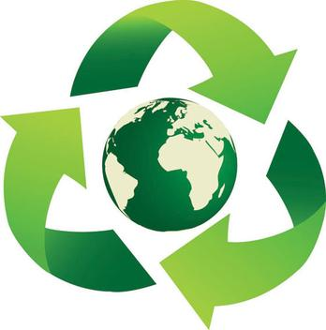
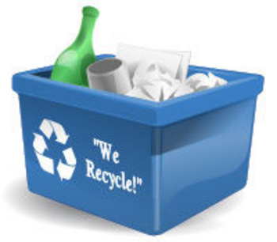
Recycle!
A can in the bin
And another went in.
Recycle! Recycle!
We all recycled and added a can.
There were two in the bin
And another went in.
Recycle! Recycle!

What is your plan to keep the Earth clean? “My plan to keep our world clean is to…”

________________________________________________________________________________________________________________________________________________________________________________________________________________________________________________________________________________________________________________________________________________________________________________________________________________________________________________________________________________________________________________________________________________________________________________________________________________________________________________________________

