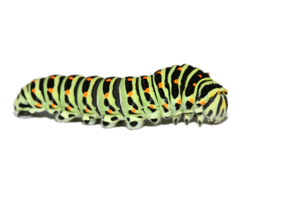
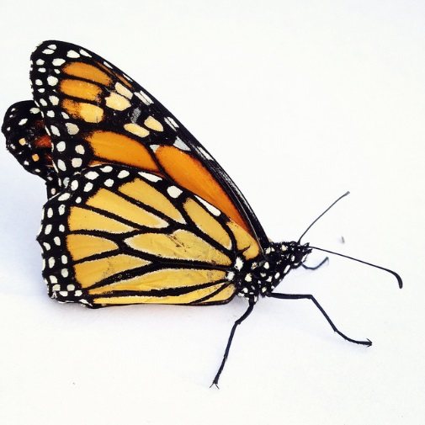
The Insect
I once was an egg.
Then I was a caterpillar.
Now I am a butterfly
And I fly, fly, fly,
I drink, drink, drink nectar
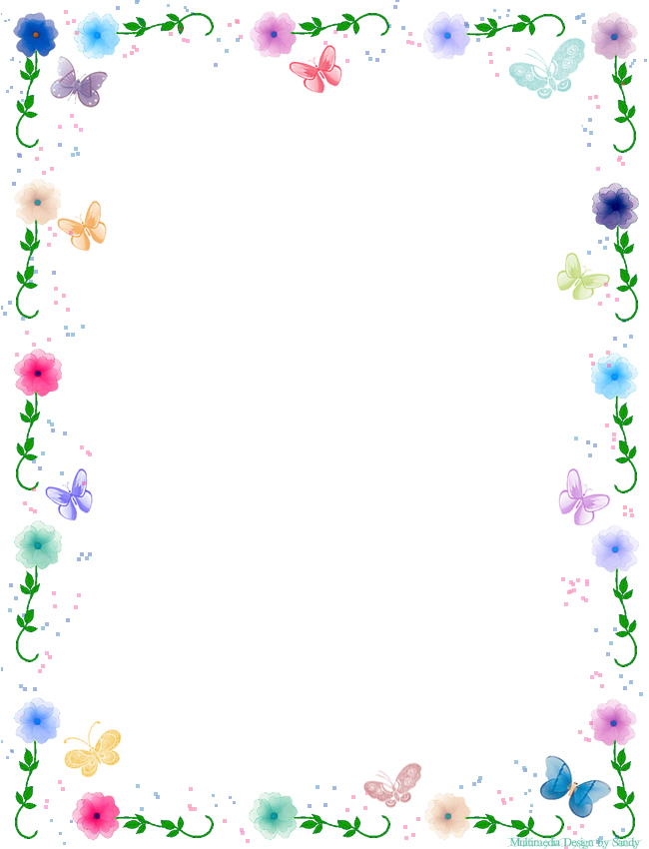

Share your knowledge or experience with insects OR Pretend you are an insect and share your adventures.

_______________________________________________________________________________________________________________________________________________________________________________________________________________________________________________________________________________________________________________________________________________________________________________________________________________________________________________________________________________________________________________________________________________________________________________________________________________________________________________________________________________________

