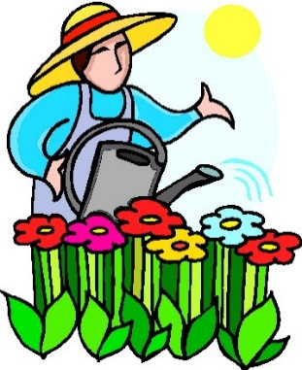
A Little Seed
A little seed for me to sow,
A little earth to make it grow,
A little hole, a little pat,
A little wish, and that is that,
A little sun, a little shower,
A little while, and then a flower!
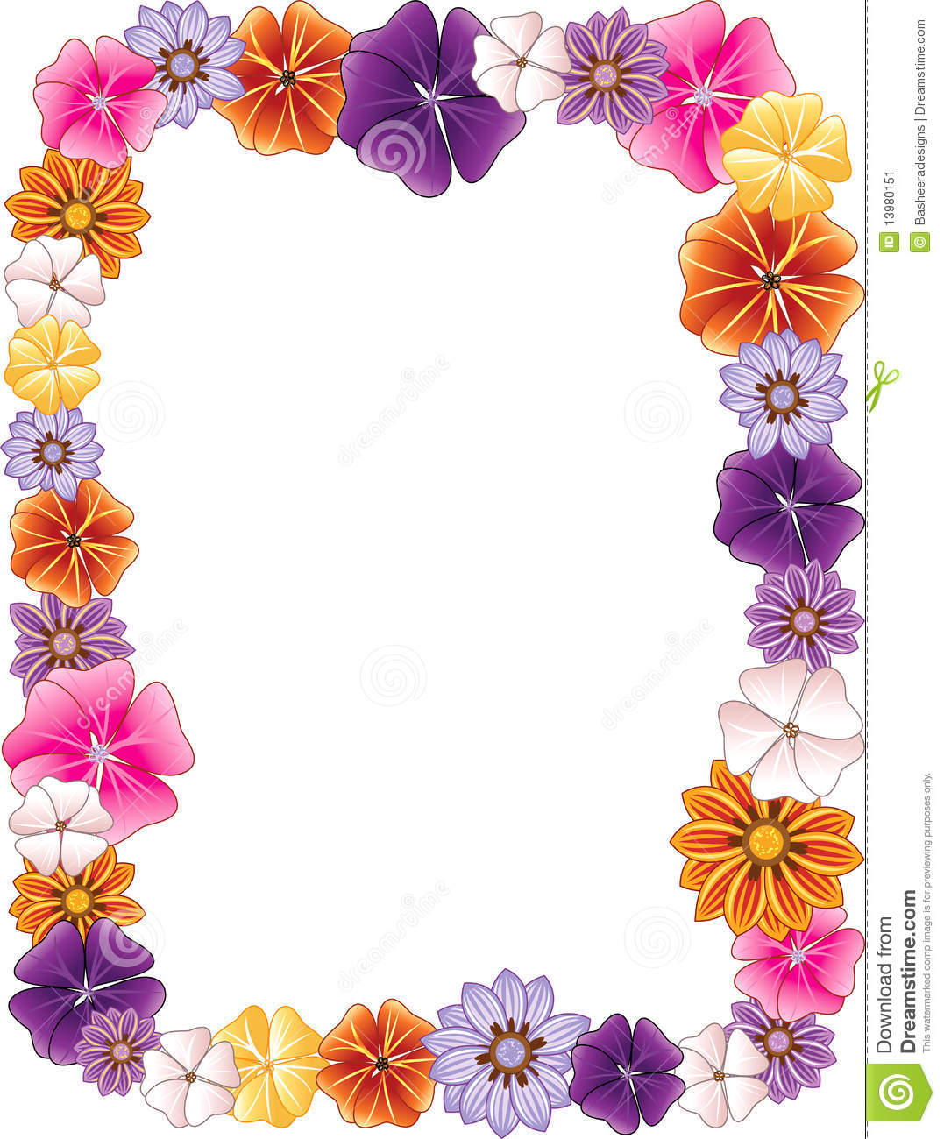

Share your knowledge or experience with growing plants. OR Pretend you are a plant and share your adventures.

________________________________________________________________________________________________________________________________________________________________________________________________________________________________________________________________________________________________________________________________________________________________________________________________________________________________________________________________________________________________________________________________________________________________________________________________

