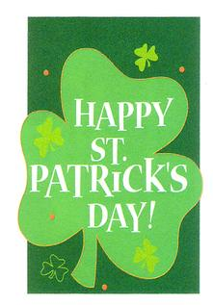
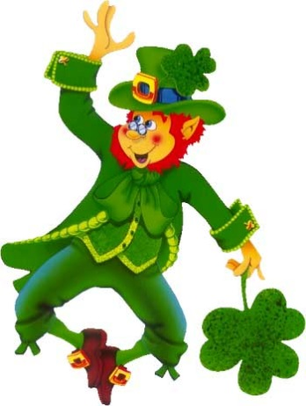
Little Leprechaun
I’m a little leprechaun
Dressed in green
The tiniest man that you have ever seen.
If you ever catch me,
So it’s told,
I’ll give to you my pot of gold.

If you caught a Leprechaun, what would your 3 wishes be?
“If caught a leprechaun here is what I would wish for. . .”
____________________________________________________________________________________________________________________________________________________________________________________________________________________________________________________________________________________________________________________________________________________________________________________________________________________________________________________________________________________________________________________________________________________________________________________________________________________________________________________________________________________________________________________________________________________________________________________________________________

