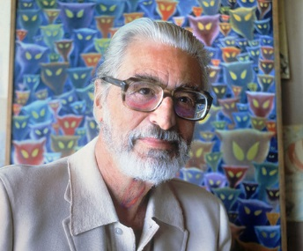
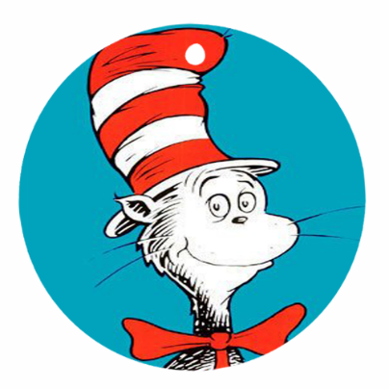
Ode to Dr. Seuss
He went by Doctor. His real name was Ted.
His books are perfect when read in bed.
He introduces us to Green Eggs and Ham,
A cat wearing a hat, and a pushy guy, Sam.
His books make us think. His books make us laugh.
His amazing work is his best epitaph.
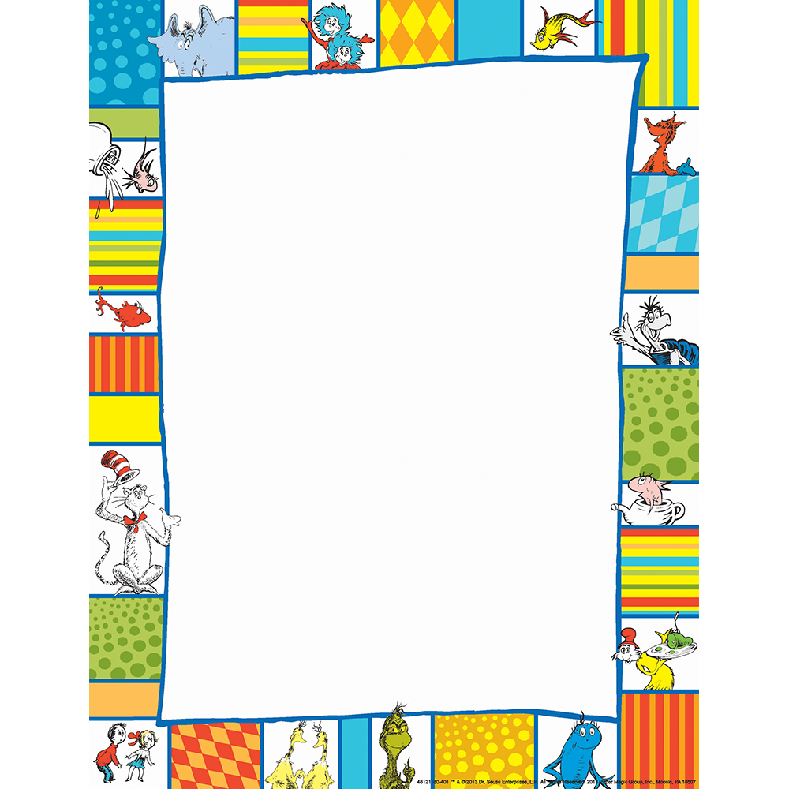

Which Dr. Seuss book is your favorite? Explain why?? OR Share a time you felt being different was a good thing!
“I think being different is great because . . .”
____________________________________________________________________________________________________________________________________________________________________________________________________________________________________________________________________________________________________________________________________________________________________________________________________________________________________________________________________________________________________________________________________________________________________________________________________________________________________

