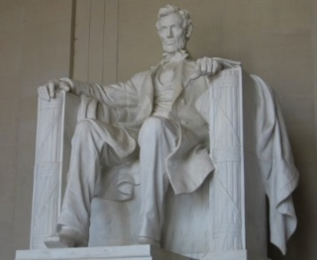
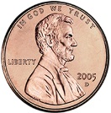
Abraham Lincoln
There was a man named Abraham Lincoln.
He proved that history can be made,
As sixteenth president he freed the slaves.
Now on some money his face will stay,
Thank you Honest Abe.
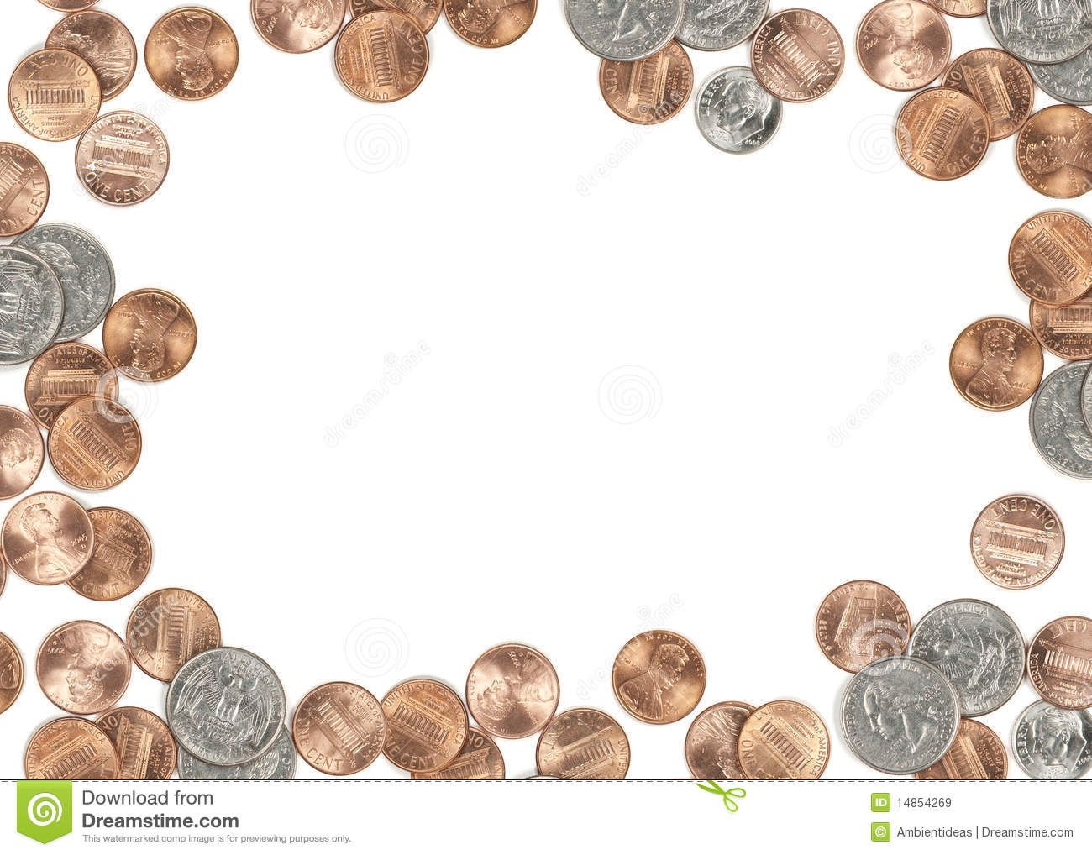

Share facts you learned about Abraham Lincoln. Why are you thankful for him being a part of American history?
“I am thankful for Abraham Lincoln because . . .”
_______________________________________________________________________________________________________________________________________________________________________________________________________________________________________________________________________________________________________________________________________________________________________________________________________________________________________________________________________________________________________________________________________________________________________

