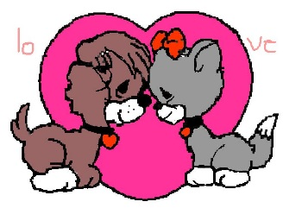
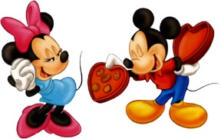
Fun to Be With
Please be my special Valentine;
there’s no one quite like you.
You’re really fun to be with,
and a very good friend, too!
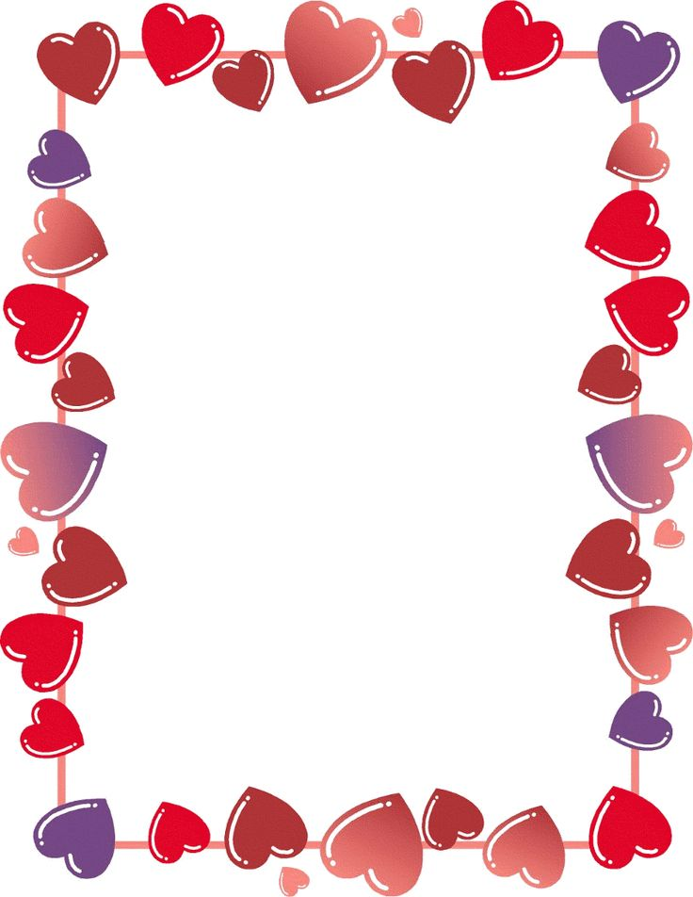

Write about what you like to most with your best friend.
“When I am with my best friend I like to . . .”
__________________________________________________________________________________________________________________________________________________________________________________________________________________________________________________________________________________________________________________________________________________________________________________________________________________________________________________________________________________________________________________________________________________________________________________________________

