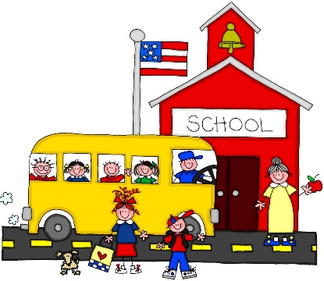
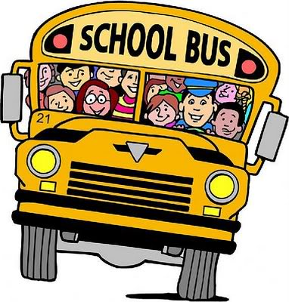
School
Hop on the bus.
No time to wait!
It’s time for school
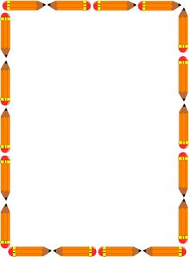
We can’t be late!

Share your thoughts about starting second grade.
“When I started second grade I was thinking . . .”
____________________________________________________
________________________________________________________________________________________________________
____________________________________________________
______________________________________________________________________________________________________________________________________________________________________________________

