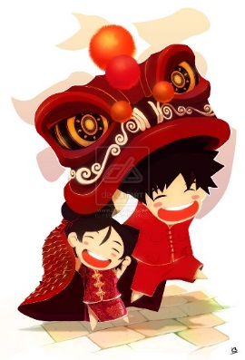
Gung Hay Fat Choy!
In China, every girl and boy
Celebrates the new year
In a very special way—
With fireworks and dragons,
They welcome in the new year
And chase away the old!

Share facts you learned about Chinese New Year. What will you do to celebrate Chinese New Year?
“What I learned about Chinese New Year is . . .”
_______________________________________________________________________________________________________________________________________________________________________________________________________________________________________________________________________________________________________________________________________________________________________________________________________________________________________________________________________________________________________________________________________________________________________

