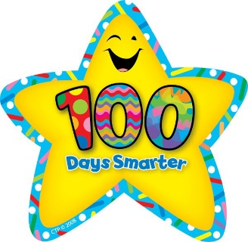
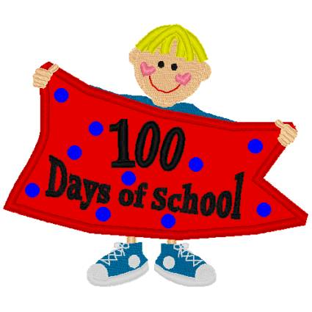
100th Day of School
100 days I’ve been in school
My teacher says, “That’s really cool!”

I’m 100 days smarter, yes, it’s true
100 days of reading, writing, and math too!
I’ve learned a lot of exciting things
Let’s see what the next 100 brings!
We’re going to have fun, we’ll let out a cheer!
Our hundredth day is finally here!

Share your favorite memory of school in the last 100 days!
“My best memory in the last 100 days is …”
____________________________________________________________________________________________________________________________________________________________________________________________________________________________________________________________________________________________________________________________________________________________________________________________________________________________________________________________________________________________________________________________________________________________________________________________________

