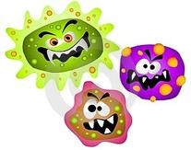
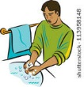
Germs!
Wash your face and hands with soap,
Wash them every day!
Keeping clean by using tons of soap
It will help keep germs away.

Explain different ways we can stay healthy OR share a time you were sick and tried to get healthy.
“There are many ways we can stay healthy, here are a few ways . . .”
“I remember a time when I was sick . . .”
__________________________________________________________________________________________________________________________________________________________________________________________________________________________________________________________________________________________________________________________________________________________________________________________________________________________________________________________________________________________________________________________________________

