**People**

****We were all made differently

****Right from the start,

But we all have feelings

And a caring heart!

Do you have a friend

Who is different from you,

Yet still you enjoy

The things that they do?

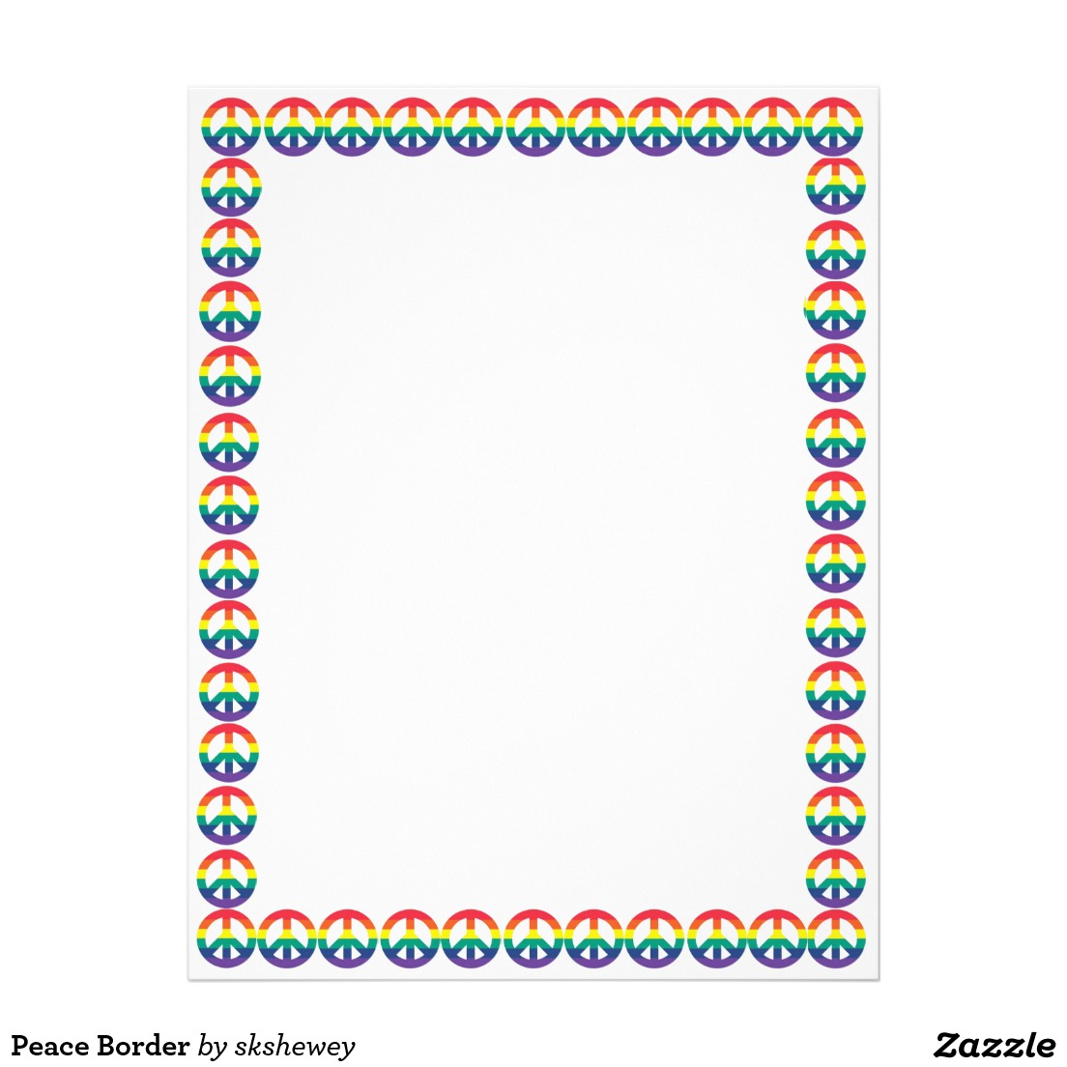

Talk about a time that you and a friend were different but could still play and work together. How were you able to agree?

“One time my friend and I disagreed about. . .”

_______________________________________________________________________________________________________________________________________________________________________________________________________________________________________________________________________________________________________________________________________________________________________________________________________________________________________________________________________________________________________________________________________________________________________