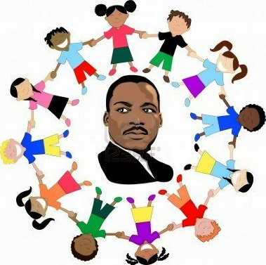
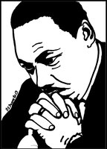
Martin Luther King Jr.
A man of peace who stood up tall.
He worked for fairness for us all.
We must be kind to one another,
Because he said, “All men are brothers.”
Martin Luther King Jr. brought us together.

Share a time that you helped keep peace and created fairness.
“I remember a time when I created fairness . . .”
OR
Tell us what you learned about Martin Luther King Jr. and how will you keep his dream alive.
__________________________________________________________________________________________________________________________________________________________________________________________________________________________________________________________________________________________________________________________________________________________________________________________________________________________________________________________________________________________________________________________________________

