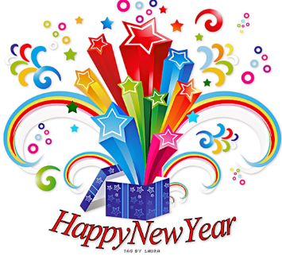
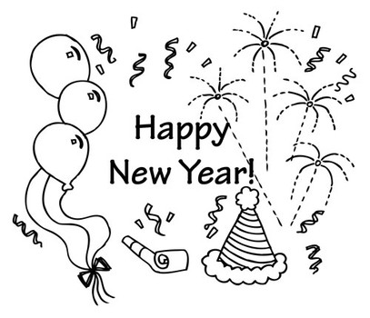
It’s a New Year
Hooray! Hooray! It’s New Year’s Day!
The day we start anew.
I’ve got so many great plans.
I’m starting right away.
Yes, this will be the best year yet.
Hooray! It’s New Year’s Day!

What are your goals for this NEW YEAR?
What do you want to achieve and focus on?
“This year my goals are to . . .”
_______________________________________________________________________________________________________________________________________________________________________________________________________________________________________________________________________________________________________________________________________________________________________________________________________________________________________________________________________________________________________________________________________________________________________

