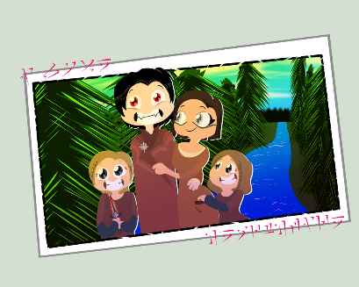
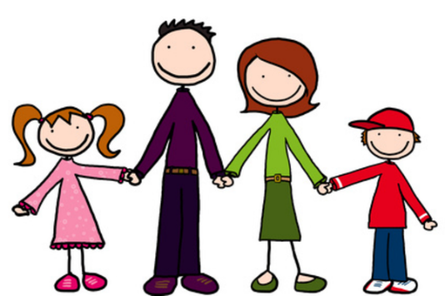
Family
Family are people
Who share that they care.
Sharing sadness and joy,
They’ll ALWAYS be there.
What kinds of things
does your family do
to show their special
Endless love for you?

Explain why your family is special to you and share a special memory together.
“My family is special to me because . . .
“I remember a time when we . . .”
___________________________________________________________________________________________________________________________________________________________________________________________________________________________________________________________________________________________________________________________________________________________________________________________________________________________________________________________________________

