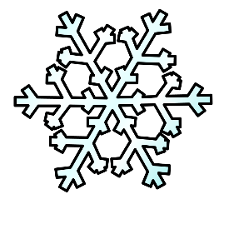
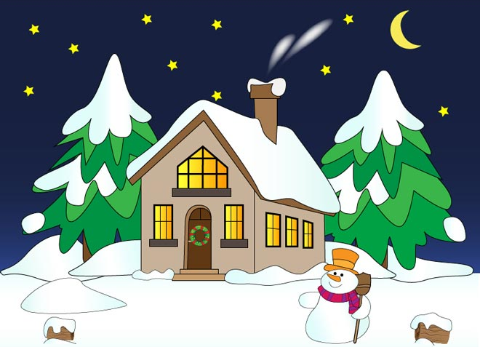
Falling Snow
See the pretty snowflakes
Falling from the sky;
On the wall and housetops
Soft and thick they lie.

Create your own story about having an adventure in the snow OR a snowman coming to life.
“Once upon a time . . .”
___________________________________________________________________________________________________________________________________________________________________________________________________________________________________________________________________________________________________________________________________________________________________________________________________________________________________________________________________________

