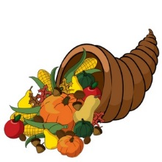
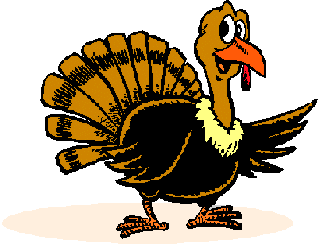
Thanksgiving Thanks
I’m thankful for the many things
That help us live as well as kings,
For all the food that makes us drool, and another holiday from school.

Share about the things in your life you are most thankful for.
“I am most thankful for _________ because . . .”
______________________________________________________________________________________________________________________________________________________________________________________________________________________________________________________________________________________________________________________________________________________________________________________________________________________________________________________________________________________________________

