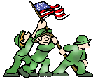
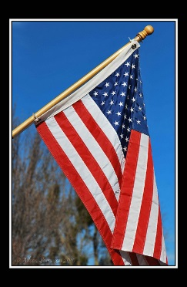
Stand for Freedom
We stood for freedom just like you
And loved the flag you cherish too.
America, respect our day
Each veteran helped freedom stay.

Why are veterans important to you?
“Veterans are important to me because . . .”
______________________________________________________________________________________________________________________________________________________________________________________________________________________________________________________________________________________________________________________________________________________________________________________________________________________________________________________________________________________________________

